# 

# Shelter Ministries Inc.

# July 2012 Newsletter

*Community Assistance* *Food Pantry* *Christmas Bureau*

## Mission Statement

Shelter Ministries Inc.

**PO Box 565**

**Auburn, IN 46706**

**260-925-9200**

**shelter.ministries.**org

**‘*Offering light and hope through the storms of life’***

Here at Shelter Ministries Inc., we strive to help the people in DeKalb County. Countless individuals and families are in great need, and we want to be here for all of the community members. We are a Christian based ministry and we know God has a purpose for us-as a ministry-and as a community.

We ask for your continued prayers for guidance and funding in order to continue our mission of “Offering light and hope through the storms of life.”

**We currently assist community members with**:

**FOOD PANTRY**: The food pantry operates under the coordination of Debbie Leon and her dedicated volunteers. We are able to assist the community through our food pantry with commodities that other food pantries cannot assist with. We are presently open every Monday from 2:30pm-6:15pm at 315 E 7th St in downtown Auburn.

**FINANCIAL COMMUNITY ASSISTANCE**: Community Assistance for DeKalb County residents incorporates giving financially to those experiencing ‘circumstantial’ poverty and connecting them with other vital community programs and resources that, when combined, offer the best hope for homelessness to be averted. Funding distributed to those who qualify comes from a mix of dollars designated from churches, Salvation Army and individual donors. We assist individuals with past due utility bills, rent, transportation to medical appointments and non-narcotic prescription medications.

**CHRISTMAS BUREAU**: The Christmas Bureau provides income-eligible families from all of DeKalb County areas with two sets of clothing, socks, underwear, pajamas and 2-3 toys for each child and a ham and a gift card from Kroger’s to finish buying the remainder of their meal for each family for their Christmas dinner. Applications are received from October through the first week of December at our ministry’s administrative office. Gifts are distributed in mid-December.

**With God’s Will and through donations, we are able to serve our community when it needs it the most.**

### May Totals

**Financial Community Assistance**

15 Households assisted => 41 Clients

$915.14 in utility help

$300.00 in rent help

$85.85 in prescription help

$15.00 in gas vouchers for medical appointments

**Food Pantry** *Special Note* Due to our relocation of the food pantry, we were only open 2 days

100 Households assisted =>282 Clients

Most clients are between ages 19 and 59

## June Totals

**Community Assistance**

16 Households => 46 Clients

$832.05 in utility help

$724.20 in rent help

**Food Pantry**

148 Households assisted => 420 Clients

8 new households, 31 new individuals

We need YOUR help! Some items needs in our food bank include:

* Cereal
* Peanut Butter
* Mac and Cheese
* Box Dinners
* Noodles
* Rice
* Box Potatoes

**We always appreciate prayer-we need guidance in this ministry to keep moving forward with what God has planned for us. Thank you!**

# Bringing you up to date: Check out our Website for more information!

If you were unaware, there have been quite a few changes to Shelter Ministries Inc.

We unfortunately had to close our doors to the shelter, but we have seized this unfortunate event as an opportunity: we now house the entire ministry under one roof. Thanks to the hard work of volunteers and workers, we are close to achieving this goal.

**Day of Caring – May 12th** We were blessed with many volunteers over the last month in assisting us with our food bank relocation.  On May 12th the United Way’s Day of Caring provided us volunteers from Group Dekko to clean and prepare the Gerig House for the food bank.  This was a full day of cleaning, scrubbing, moving furniture and so much more.  We were provided with two large dumpsters from Omni Source which we filled and then some… We were also provided a semi-trailer from JAT to store furniture and other items removed from the house to make room for the food bank.  The Group Dekko volunteers were very helpful and appreciated.  We also appreciated the dumpsters provided from Omni Source.

**Food Bank Move - May 19th** On May 19th we were blessed again with a number of volunteers from Resurrection Lutheran Church to help relocate the Food Bank from the Wayne Street location to the 7th Street location.  The move consisted of relocating all of the shelving, freezers, refrigerators and food.  This was also a full day of work in near 90 degree weather.  The food bank was closed for 2 weeks in order to continue to prepare for reopening which occurred on June 4th.  The food bank volunteers and Deb Leon worked hard to get the bank organized and ready to serve clients in the community.  We did experience some issues with the air-conditioning at the Gerig House and a freezer problem that caused a freezer full of meat to be lost; however, it was a successful move.  The food bank now has considerably more room to store food to better serve our community and save over $500 a month on renting space and the utilities at the old site.

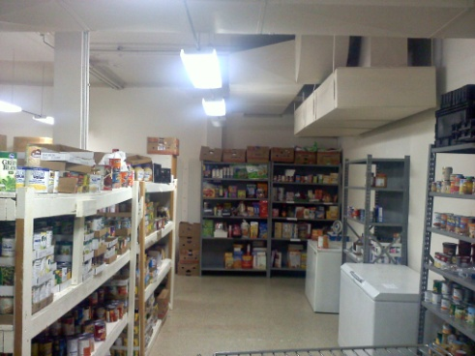 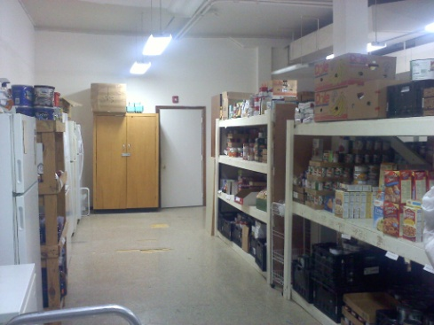

**Rummage Sale – May 25th-26th**

The process of moving all the residency area items, large and small, during the Day of Caring and in order to make room for the Food Bank seemed daunting. What were we going to do with *ALL* of the stuff? We did what worked for the best interest of the community: raise money through a rummage sale! We unloaded the trailer, which was full from back to front and top to bottom, with the help of a few young strapping young men and set up for the rummage sale. All of the proceeds went directly to assisting the community. In two days, we were able to raise over $2000.00! All of the furniture and small house appliances that did not sell were donated to The Mustard Seed Furniture Bank of Fort Wayne. The Rummage Sale went very well; make sure to be on the lookout for another sale over Labor Day Weekend!

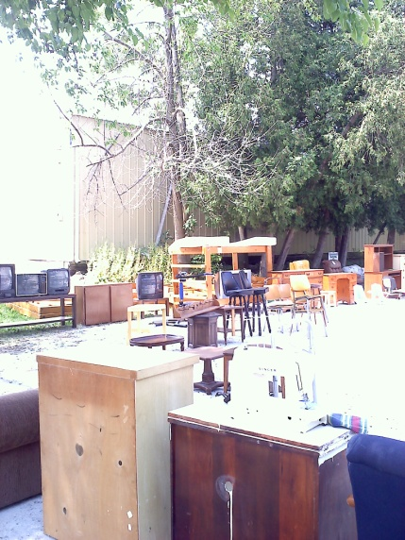 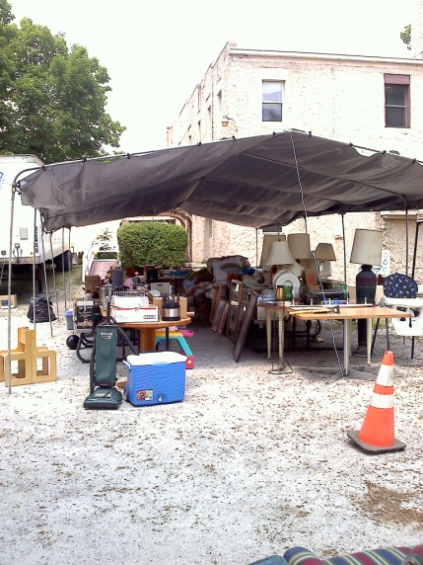

**THANK YOU!!**

Thank you to our volunteers:  
Group Dekko, Resurrection Lutheran Church, Christine Simpson, Coltyn Miller, Julie Miller, Tom Fisher, Daniel Gentis, Colby Stackhouse, Julio Padilla, Anne and Roger Brandenburg, Ruth Smith, Rachel Glaser, Brian Wessley and family, Bill and Jean Ferrell, Dr. J Robert Edwards and G Edwards, Emily Ferrell, Bob and Debbie Leon, Tamara Clark, Rusty Harter, Bonnie Huffman, Kathy Myers, Fala Winslow, Anggela Young, Jim Reinsch, Eric Joseph, Terry Sterling, Raschelle Fleming, Darline Mavis, Tina Clair, Tasha Clair, Iola Winslow, Shirley Frost, Annette Ruth, Vera Leon, Donna Greenfield, Chris Leon, Brenda Jacobs, Becky Leon, Mildred Gaff, Tony Bell and numerous others! Thank you all!

*We need your input!*

We want to send out newsletters to community members! Please let us know how you would like to receive your Shelter Ministries Inc. newsletter!

Phone: 260-925-9200

Email: shelter. ministries.auburn@gmail.com

(If email is your choice, let us know what

Email address to send it to!)

Mail: PO Box 565 Auburn, IN 46706



Shelter Ministries Inc.

PO Box 565

Auburn, IN 46706

